Roles
Monitor lifeguard
Drug pusher
Documenter

Airway assistant
C-spine stabilizer
Intubator

INTUBATION CHECKLIST
Adapted from Greater Sydney Area-HEMS checklist
Monitor Lifeguard or Assistant reads
Intubator checks and responds

Situation briefed Check
Resuscitation maximized Check
Roles assigned Check

SET-UP
P.P.E. Check
Position optimized Check
Oxygen sufficient, maximized and preoxygenated Check
O2 Mask at 15 liters, Nasal at 15 liters Check
Suction tested/ Gastric suctioning/ In-line suctioning Check

IV/MONITORS/DRUGS
Two I.V.’s working Check
Monitors visible: Sat Cardiac BP Check
B.P. cuff cycling, opposite sat/IV arm Check
Drugs ready: Induction + Paralytic? Check
Fluids + or - Pressors? Check
Post analgesia / sedation? Check

EQUIPMENT
B.V.M., PEEP, Oxygen, End-tidal CO2 Check
O.P.A., N.P.A. Check
Laryngoscope tested Check
Endotracheal tube and Syringe Check
Cuff tested and lubed Check
Stylet and Bougie Check
Extra tube, Tube tie Check
Alternate laryngoscope, Supraglottic airway and Cric kit Check

TEAM BRIEF
C-spine assistant briefed Check
Risks discussed Check
Fail plan briefed Check
E.L.M. & bougie plan briefed Check
Desat trigger and plan briefed Check

Any other questions and concerns?

CHECKS COMPLETE – ANESTHETIZING AT _ _ : _ _
Yen Chow @TBayEDguy 2016-04-14

Succinylcholine contraindications
BRIEFING

Situation
What’s going on

Task
What we need to do

Intent
The reason is

Concerns
Watch out for

Calibrate
Other thoughts/ideas?
Malignant hyperthermia Organophosphates
PROLONGED DURATION
Organophosphate tox
Eaton-Lambert Syndrome*
Pseudocholinesterase def, Hypothyroidism

NEVER USE (K+ release+++)
Malignant hyperthermia
Hyperkalemia, Crush injury
Myopathy, Muscular dystrophy
Amyotrophic Lateral Sclerosis, Multiple Sclerosis
Guillain-Barre, Botulism, Tetanus
Burns ≥ 2ndº >10% BSA >5 days until healed
Stroke + hemiparesis, Spinal cord injury >5 days until 6 months post injury
Severe intra-abdominal sepsis >5 days until resolution

Hyperkalemia (known or concern), Crush injury Pseudocholinesterase def
Myopathies/Muscular dystrophies Myasthenia gravis(?)
Amyotrophic Lateral Sclerosis, Multiple Sclerosis
Guillain-Barre, Botulism, Tetanus
Burns ≥ 2nd degree over 10% BSA >5 days until healed
GIVE MORE
Myasthenia Gravis** (lasts long tho)

Stroke with hemiparesis, Spinal cord injury >5 days until 6 months post injury
Severe intra-abdominal sepsis >5 days until resolution
NO PROBLEM
Parkinson’s Disease
Epilepsy
Acute CVA or spinal cord injury

*Sensitive to BOTH depolarizing and non-depolarizing neuromuscular blockers
**Resistant to succinylcholine; BUT avoid non-depolarizing, response unpredictable, use ½ dose

Intubation drugs
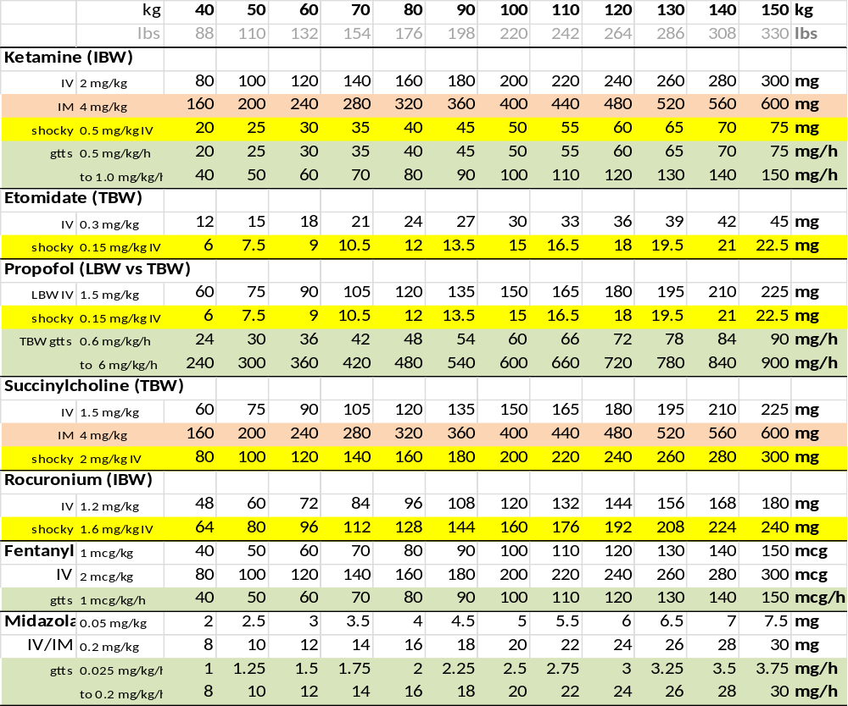
Yen Chow @TBayEDguy 2016-02-07

POST-INTUBATION
Reassess ABCD vitals Check
ETT secured Check
Tube depth, ETCO₂ waveform, Cuff pressure Check
In-line suction ready Check
Analgesia/Sedation Check
Supplies (oxygen, drugs, power) Check
Ventilator settings Check
Head of Bed raised 30 degrees Check
Gastric tube & Foley prn Check
Secure all lines and tubes Check
Rescue airway equipment nearby Check

Post debriefing

What was planned?
List objectives and expected actions

What actually happened?
Review any actions not standard operating procedure
Review any safety concerns

Why did it happen?
Reasons for ineffective or unsafe performance

What can we do next time?
Identify effective and ineffective performance
Determine how to apply the lessons learned to the next time

Yen Chow @TBayEDguy 2016-02-07
12 (3x4) Step Response to desaturation
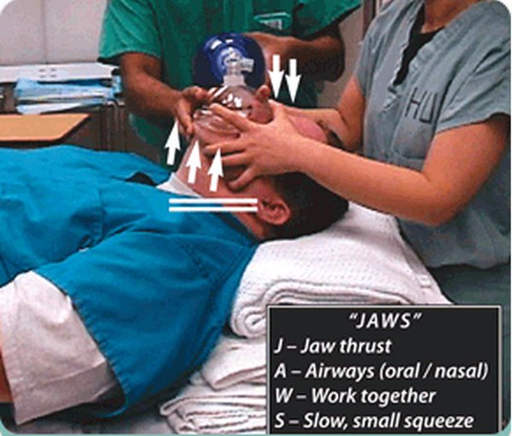
BVM | PEEP 15 | Mask 15 LPM | Nasal 15 LPM
OAW/NPA | Jaw thrust | Two person | Mask seal  Jaw thrust  Airways (oral / nasal)  Work together  Slow small squeeze  from Rich Levitan  @airwaycam
Upright lungs, position head / neck | Clear FB fluids | Coordinated slow small squeeze underhand | Pulse ox lag? Shock?

Sex (6) Steps to BVM (adapted from Jason N. Cook @cptjcook “#SexyBagging”)
OPA/NPA | 2 thumbs down jaw thrust | 2 person BVM | position | ventilate carefully with coordination | PEEP
Optimize each airway attempt by
Manipulations (head neck larynx device)
Adjuncts
Suction
Change size/type
Oxygenation, O2 flow, PEEP
address Tone
adapted from #Vortex @VortexApproach
Nicholas Chrimes @nicholaschrimes and Peter Fritz @pzfritz

Airways (OPA NPA)
BVM and PEEP
CO2 end-tidal and confirm (stethoscope)

Suction(s) /Gastric /In-line /Magills /MecAsp
Laryngoscope and alternates
Oxygen (pre re and apOx, switch sources)
Positioned
Endotracheal tube cuff lubed tested syringed
Stylet Bougie SGA Surgical airway

Monitors, Meds, IV, BP cuff cycling opp arm
Assistants and roles assigned, tasks briefed
ELM Bougie
Plan, approach, fails, risks

Assistants help, add or maintain
- Oxygen line switch (NRB to BVM)
- Collar opening, c-spine stabilization
- Cricoid pressure (optional, release if prob)
- Extra suction, operate vent hole
- External Laryngeal Manipulation
- Bougie prepass and 2 person bougie
- Head elevation
- Extra laryngoscope lift
- Jaw thrust
- Mouth opening/ Pull right corner mouth
Teaching Handout Yen Chow @TBayEDguy 2016-06-16
30s drilled response encountered/anticipated difficulty
1) Release/relax cricoid
2) Extra head elevation (towels folded)
3) ELM bimanual laryngoscopy (assisted prn)
4) Extra laryngoscope lift (lock elbow in)
5) Use Mac as Miller (esp if Mac4)
6) Bougie (get grade 3a view)
Also Breathe Relax Expose then Sight Deliver, +/-…
1) More jaw thrust/mouth opening
2) Check position patient/intubator
3) More/better suction
4) Change Blade/ Device size/type Technique (e.g. right paraglossal straight blade)
5) Change intubator (best experienced)
6) Address patient tone, cooperation, muscle relaxation
7) Control tongue, ID/control epigl, see notch
8) Use right corner of mouth/right cheek pull
9) Straight to cuff styletting
10) Pass styletted tubes/bougies below line of sight
11) Left turn at Laryngeal inLet on railroading ETT over bougie
12) Right turn tube tip hitting tracheal Rings
Each next attempt MUST Address difficulty encountered and Change something

